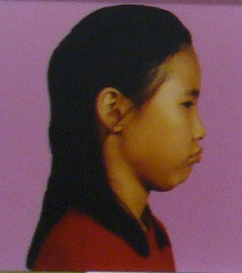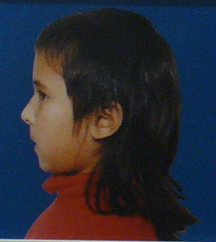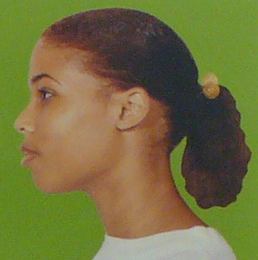

Face-to-Face:
Dealing with Prejudice and Discrimination

Teacher’s Guide

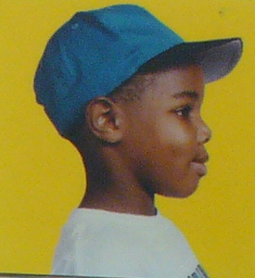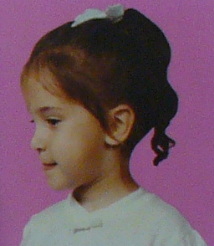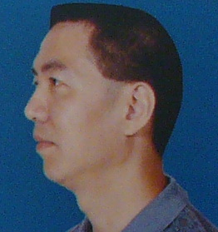
Dear Educator,

We are happy that you will be bringing your class to Kidsbridge’s Mini-Museum at The College of New Jersey. Along with interacting with the Face-to-Face: Dealing with Prejudice and Discrimination exhibit, your students will gain exposure to a college campus and see what they can aspire to. The exhibit focuses on unity, diversity appreciation, and dealing with prejudice and discrimination in our daily lives. It also hopes to give children positive strategies to use when dealing with difficult situations, i.e. a bystander situation. The visit will also include a pre- and post-assessment by the TCNJ Psychology department to evaluate the students’ learning.

Before your visit…
To ensure that you and your students have the best possible experience, please consider discussing the key terms included in this guide. A packet of pre- and post-visit activities, which are designed for your grade-level, is available to help prepare and reinforce the exhibit’s message.

About your visit…
Your visit will consist of several components. First, a pre-assessment will be administered to the students. This will be followed by the interactions with the Face-to-Face exhibit, including extra activities like puppet making, skit preparation and puppet shows. Occasionally, we are able to bring in a college student with a disability to talk about the challenges that their disability has created. Lunch will follow. The “Aspiration to College” campus tour is provided upon request. Finally, a post-assessment will be administered to evaluate learning. A full schedule detailing the exact times for each component of your visit is included in this guide.

It is our hope that this visit will help your students to realize the importance of cultural diversity, kid heroes, community service and tolerance. If you have any questions or concerns about your visit, please do not hesitate to contact us.

We look forward to your visit!

Kidsbridge Tolerance Museum
www.kidsbridgemuseum.org
TENTATIVE Schedule of Events

9:00 – 9: 30 am Buses arrive on TCNJ campus

9:30 am - 9:45 am Pre-survey - assessment

9:45 am - 11:30 am Museum Exhibit exploration

11:30 am - 12:15 pm Skit preparation/focus on disabilities

12:15 am - 1:00 pm Lunch and puppet show

1:00 PM- 1:15 pm Post survey –assessment

1:15 Culmination exercise

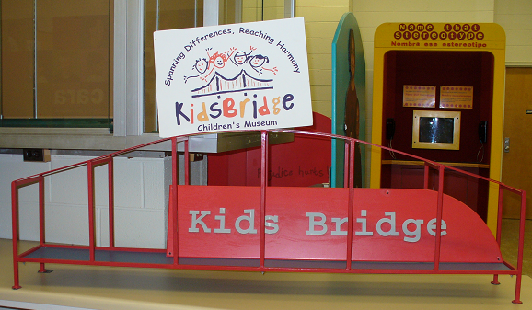
This program satisfies NJ Core Curriculum Content Standards in:

1. Visual and Performing Arts
2. Health and Physical Education
3. Social Studies
and Career Education and Life Skills

The program objectives are:

- To learn about stereotypes, prejudice, and discrimination and the effects they have on others within our society.

- To achieve greater understanding and respect for oneself and others through an interactive and experiential process.

- To develop necessary skills to deal with prejudice and the emotions that arise from prejudice and discrimination.

Students will:

- Explore various approaches to dealing with prejudice and discrimination by examining the experiences of other children.
- Feel they are not alone in being subjects of prejudice and discrimination.
- Learn that name calling is a form of prejudice and discrimination and explore their emotions about victims of name calling (and how to handle it).
- Understand that exclusion is a form of prejudice and discrimination and that being a silent bystander is comparable to doing a harmful action.
- Explore differences through exposure to a collection of diverse images of people.
- Learn to recognize and dispel stereotypes.
- Learn that creative expression takes a variety of forms, such as art, writing, and music, and that each one can be a powerful means of communicating feelings and experiences.
- Feel inspired and empowered to take action against prejudice and discrimination.
- Gain a historical perspective of prejudice and discrimination through studying historical signage and photographs.
Key Terms and Definitions

Bullying: To intimidate others in order to get one’s way.

Compassion: Understanding the way another person feels and wanting to help them.

Discrimination: To judge people based on a group they belong to rather than their individual characteristics.

Diversity: Being different from one another.

Ethnicity: A person’s connection to their race, religion, language, nationality or culture.

Emotions: A reaction produced by strong feelings, like anger of sadness.

Multiculturalism: When many cultures are part of the same community and keep their uniqueness.

Prejudice: An opinion about a person or group formed without knowing facts.

Race: A group of people sharing common physical features.

Racism: Believing that one race is better than others.

Sexism: Believing that one gender is better than another.

Stereotype: An idea about a group of people that is not based on facts.

Tolerance: Accepting the race, religion, language, nationality, culture and opinions of others. Being open-minded.

Unity: Living peacefully together.
Campus Map, Directions and Parking

Directions to TCNJ Campus

From I-95:

Using I-95, take exit 4 (Route 31/Pennington Road). Bear to the right off the exit ramp, you will be traveling south on Route 31. At the second traffic light (about 1.5 miles), make a left into the College entrance.
From the College entrance:
Make a right onto the main access loop around campus. Park in Lot 3 or 4, located on the left side of the drive. Buses: drop off is Brower Student Center (see X on map).

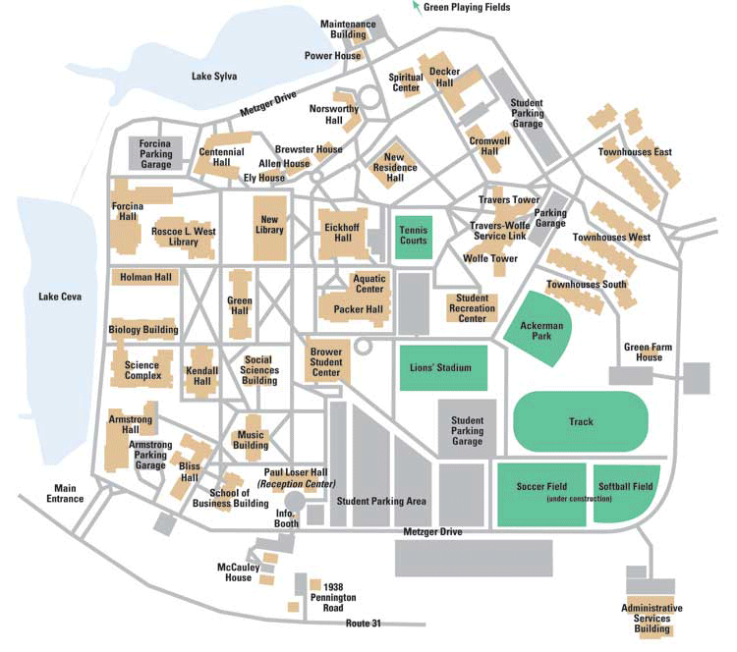
Museum Exhibits

Kids Bridge:

Children share their stories of prejudice and explore how to respond to discrimination.

Name That Stereotype:

The students are instructed to press a button when they hear a stereotype mentioned. The host provides feedback, and students learn to recognize different types of stereotypes. They will learn that people use stereotypes and that people should not judge others by how they look or by the group they belong to.

Peace Diner:
Students take a seat at The Diner and listen to a tape of name-calling. They will hear how one boy deals with name-calling and learn strategies that they can use if they are ever called a name. The strategies are written on plastic pieces, which the children can choose and place on a “power pack” in front of them. Once they have chosen the strategies that they are most comfortable with, they can role-play the responses with an adult. They will learn that it is not all right for people to call others names, and that there are positive choices when name-calling happens to them or to other children.

School Bus Showdown:

This exhibit is an interactive video station featuring a video of a school bus scene in which a child is being taunted while looking for a seat. Several children have room for her in their seats, but only some scoot over. The video explores the reasons for the children’s actions. A response board is included in this station where students can write down their feelings about being a bystander and any strategies they have for standing up for a peer.

Turn and Learn About Differences:

This exhibit is an enlarged replica of the children's toy "See and Say." It has a wheel that contains pictures of diverse individuals and families. When a student pulls the lever the arrow will spin and eventually stop on one of the pictures. The individual will verbally describe a challenge or stereotype he or she has overcome. At this area students will discover individual differences through pictorial and verbal representations. They will learn about and dispel common misconceptions.

Talk Back Board:

At this station, visitors will add their thoughts to a continuing anti-prejudice and anti-discrimination board. This will allow them to give the museum personal responses on their own experiences.

Taking a Stand Pledge:

Here, students will have the opportunity to sign their names to a petition against prejudice and discrimination. This will help them to be inspired and empowered in the fight against hate. It will also highlight the importance of collective action in the community.

Signs of the Times:

This area is a wall of reproductions of signs, news articles and pictures. These images share instances of prejudice and discrimination that have occurred in the history of the United States and Canada. Each image is accompanied by a description. There is also a list of various groups of people that have been victims of prejudice and discrimination, along with famous historical faces. The students will learn about the historical impact of this injustice among many people, as well as understand that these issues are ongoing.

Personal Power Charger Station:

This center is a craft area in which students will make "personal power chargers." This craft is designed to be a self-esteem charger, which includes statement starters like "I have the power to..." and "I am proud because I am..." Here, students will learn to stand up for their beliefs and be reminded of why they should feel good about themselves.

Telling Our Stories, Testimonial Video and Resource Area:

This station has three components. First, there are accounts written by prior students of their personal experiences with prejudice and discrimination. Current visitors can write down their experiences and add them to the collection binder. They will see how other kids feel and deal with these situations, as well as add their own thoughts. Secondly, there is a large monitor that shows video clips of children telling true stories of prejudice and discrimination. Here, again, students will observe the experiences of peers. Finally, there is an area containing resources, bookshelves and seating. It is a comfortable place for reading and expression where students can explore and respond to the resources and thoughts of the museum.
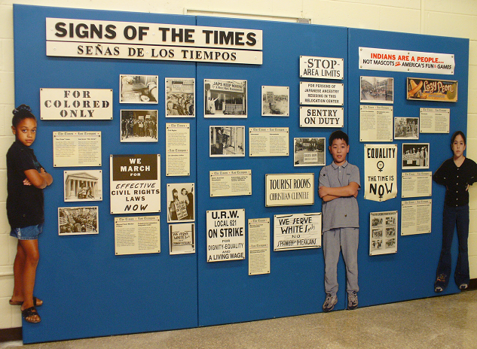
NEW MUSEUM EXHIBITS

Darfur (for Middle School)

The Darfur exhibit facilitates engagement in issues surrounding the modern-day genocide going on in Darfur. The exhibit contains children’s artwork by children in Darfur in response to the on-going violence in their daily lives and provides a visual and powerful representation of this horrific manifestation of prejudice, discrimination and racial genocide.

Visitors Will:
- Gain an understanding of events going on in Darfur.
- Learn how the events are affecting families and their lives.
- Explore ways to help i.e. fundraisers.
- Write a letter to their Congressman/President.
- Learn about online email advocacy.
- Learn about Doctors Without Borders
- Learn about the power of grassroots advocacy.

Questions to Ask Youth:
- Why is learning about incidents of genocide important?
- Are we powerless to act and make a difference?

Questions to Expect:
- What is genocide?
- Why is it happening?
- What can I do to help?

Sensitivity to Persons with Disabilities (All)

Visitors to this exhibit learn to better understand others with disabilities through hands-on activities, the use of person-first language, and group discussion designed to promote empathy and acceptance of people with disabilities.

Visitors Will:
- Explore what it would be like to have a disability.
- Learn how others feel and deal with having disabilities.

Questions to Ask Children:
- How did you feel during the activities?
- Why did you feel that way?
- What has the activities showed you?

Questions to Expect From Children:
- Why do I need to do these activities?
- What is it like to be disabled?
- How do I behave towards someone with a disability?

Kid Heroes (All)

Visitors to the Kid Heroes room will look at kid heroes their age, listen to inspirational stories of young heroes, collaborate with classmates on who can be called a hero, and ultimately to see the heroes within.

Visitors Will:
- Share their hero stories.
- Learn that everyone can be a hero.
- Be inspired by kids doing community service.

Questions to Ask Children:
- What makes someone a hero?
- Why do we have heroes?
- What is a celebrity?
- What is the difference between a celebrity and a hero?
- Is Brittany Spears or Miley Cyrus a hero? Why or why not?

Questions to Expect From Children:
- Why are heroes important?
- How can someone my age be a hero?

Kidsbridge Tolerance Museum

Mission:
Kidsbridge, a nonprofit organization dedicated to the celebration of human diversity, encourages the students, families and educators of the greater Mercer County region to understand and appreciate the strengths and opportunities that are inherent in the diverse, mosaic cultures of our community and our world.
Kidsbridge also provides programs that create measurable improvements in character education and life skills. Our character education programs generate positive learning in civility, kindness, conflict resolution, mediation and anti-bullying. Our life skill programs are designed to prepare children to be successful in a global society, while instilling the time-honored values of cooperation, peaceful interaction, teamwork and leadership.

The Tolerance Museum at The College of New Jersey
In January 2006, Kidsbridge Tolerance Museum finalized the creation of a mini-museum a.k.a. learning lab on campus at The College of New Jersey — a highly accredited college in New Jersey. The mini-museum features “Face to Face: Dealing with Prejudice and Discrimination,” an exhibit created by the Chicago Children's Museum that focuses on diversity appreciation and tolerance.
Kidsbridge Tolerance Museum and The College of New Jersey (TCNJ) are collaborating to create a cutting edge partnership to teach diversity appreciation and character education to elementary school children.
This exhibit, in 2006, has reached more than 5500 children, 200 parents and guardians, 400 college elementary and pre-school undergraduate education majors, 25 undergraduate psychology majors, 50 student teachers and other partners in the greater Mercer County community.
TCNJ undergrad students majoring in Education will have the opportunity to teach children visiting the mini museum and undergraduate psychology students will be assessing students before and after their visit. Volunteers from the campus and community will be coordinated by The Bonner Center for Civic and Community Engagement.

If You’d Like to Help:
- Financial contributions* are very much appreciated. Thank you in advance for supporting our mission and a new interactive tolerance museum in Trenton.
Please forward your support to:
Kidsbridge Tolerance Museum, 4556 So Broad St, Trenton, NJ 08620
Or online at https://journals.eventjournal.com/view_joinus.php?journal_id=193&page=donate OR visit www.kidsbridgemuseum.org and click on Contribute

Please contact Lynne Azarchi, Executive Director, at (609) 581-0239
if you need more information.
*Contributions are tax-deductible according to limits prescribed by law.
- Volunteer Opportunities include being a Docent for the Museum, working with the Education Committee, Event Committee, Fundraising Committee, Disability Awareness/Sensitivity Committee, Grant Writing.

PARTNERS

Kidsbridge - Lynne Azarchi, Executive Director

The College of New Jersey
Dr. Carol Bresnahan, Provost
Dr. Bill Behre, Dean, School of Education
The New Jersey Commission on Holocaust Education –
Dr. Paul Winkler, Executive Director

Contact Information: KidsBridge Inc.
Email or give us a call today at (609) 581-0239
Lynne Azarchi
Executive Director
lynnekidsbridge@aol.com

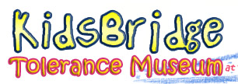

Empowering youth to make positive changes
in themselves and in the world !!!

